VoterInformation

Table as per design

The Data Type are the same

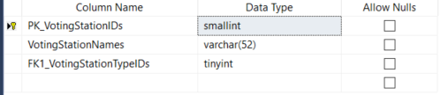

Rows retrieved 234 rows

Executing

“SELECT * FROM VotingStationName ” all row was returned (234 rows)

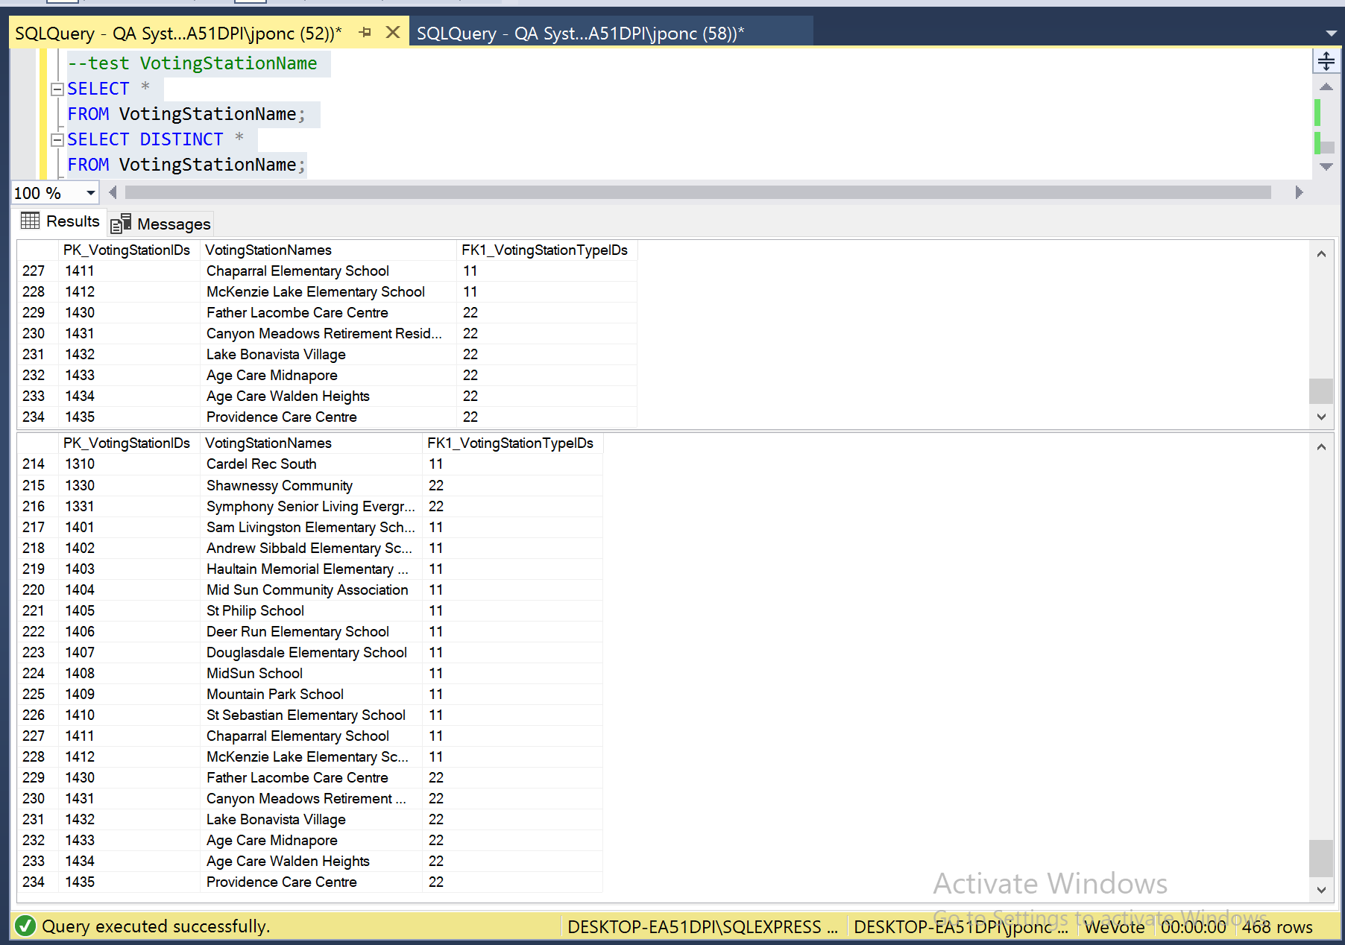

Data Manipulation

Primary Key related to other table and with Foreign Key

Executing

“ Begin Transaction Delete Top(1) from VotingStationName ROLLBACK ”

Error “The DELETE statement conflicted with the REFERENCE constraint "FK2_VotingStationIDs". The conflict occurred in database "WeVote", table "dbo.VoteCounts", column 'FK2_VotingStationIDs'” was generated.

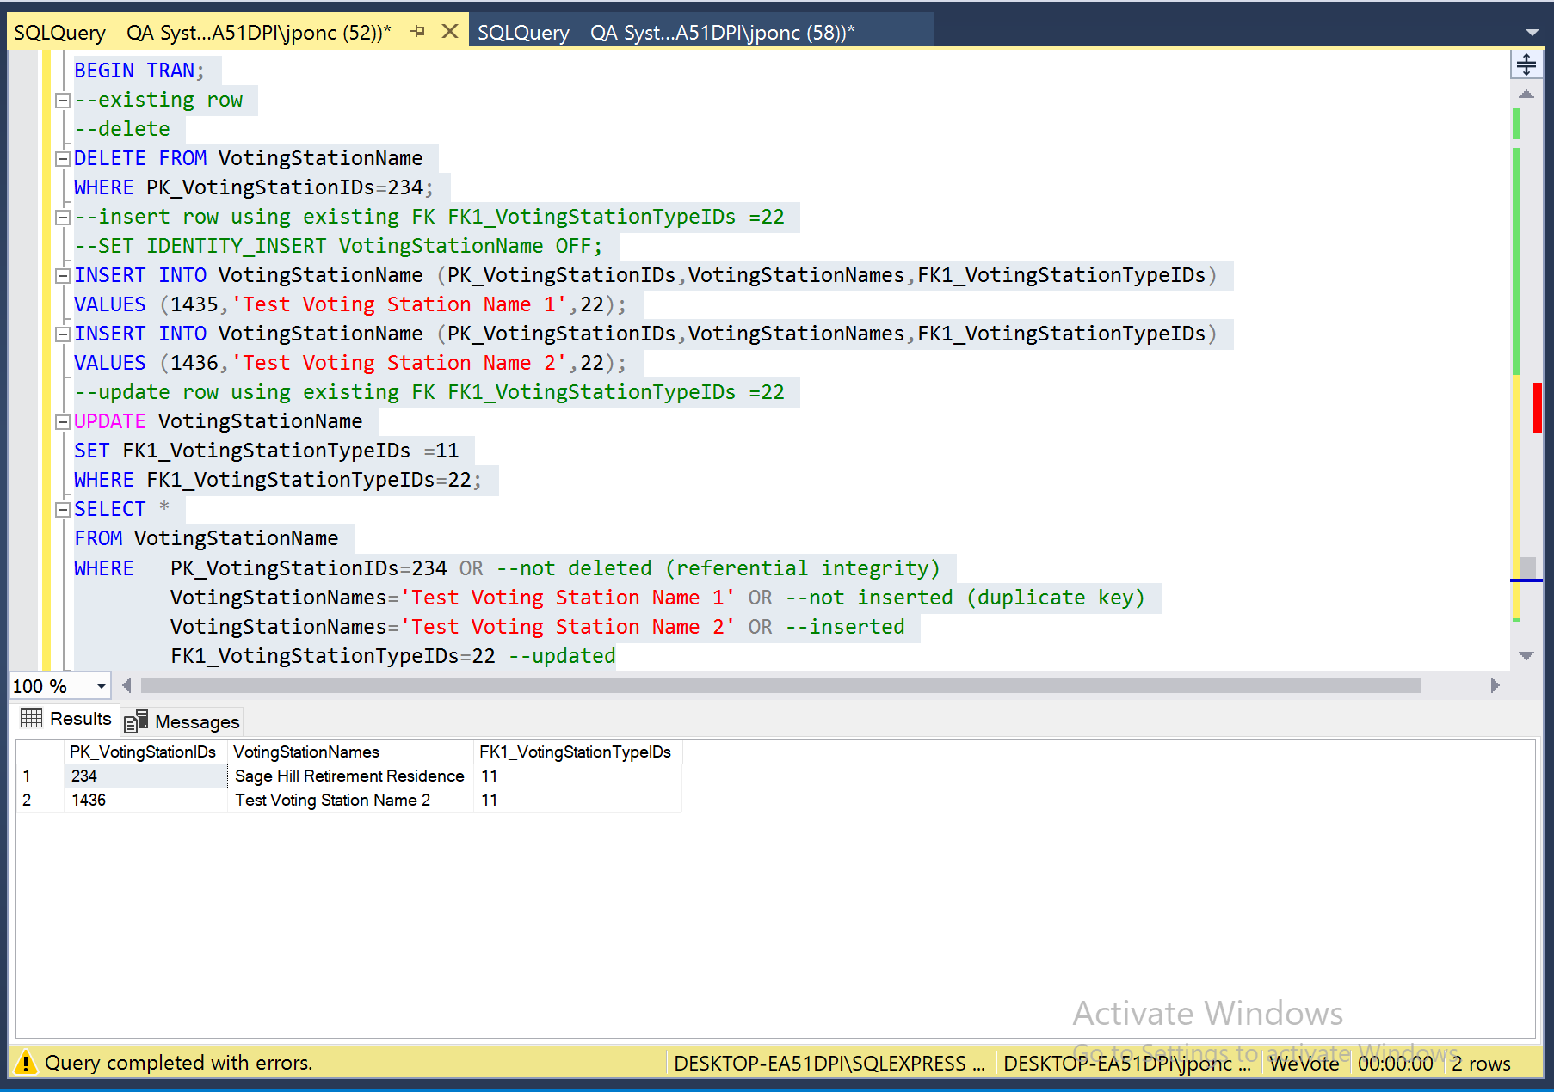

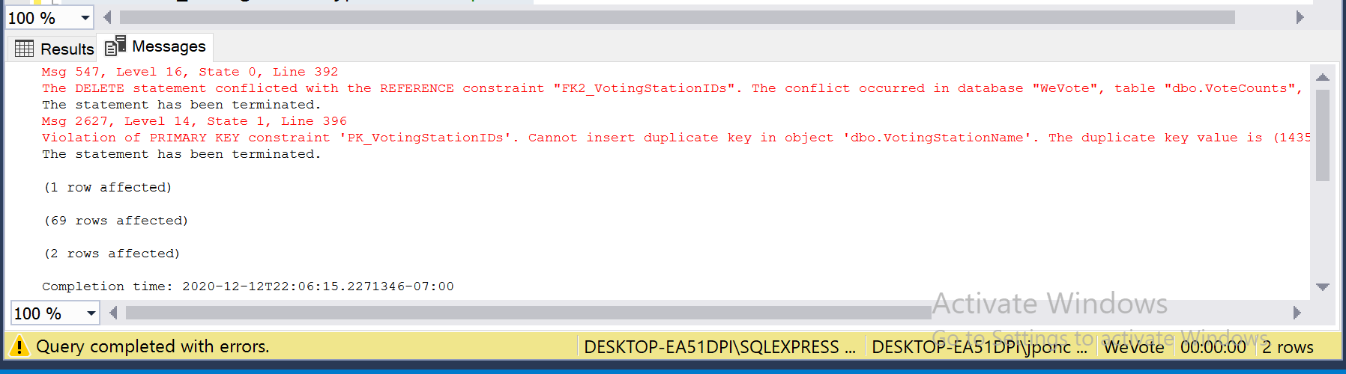

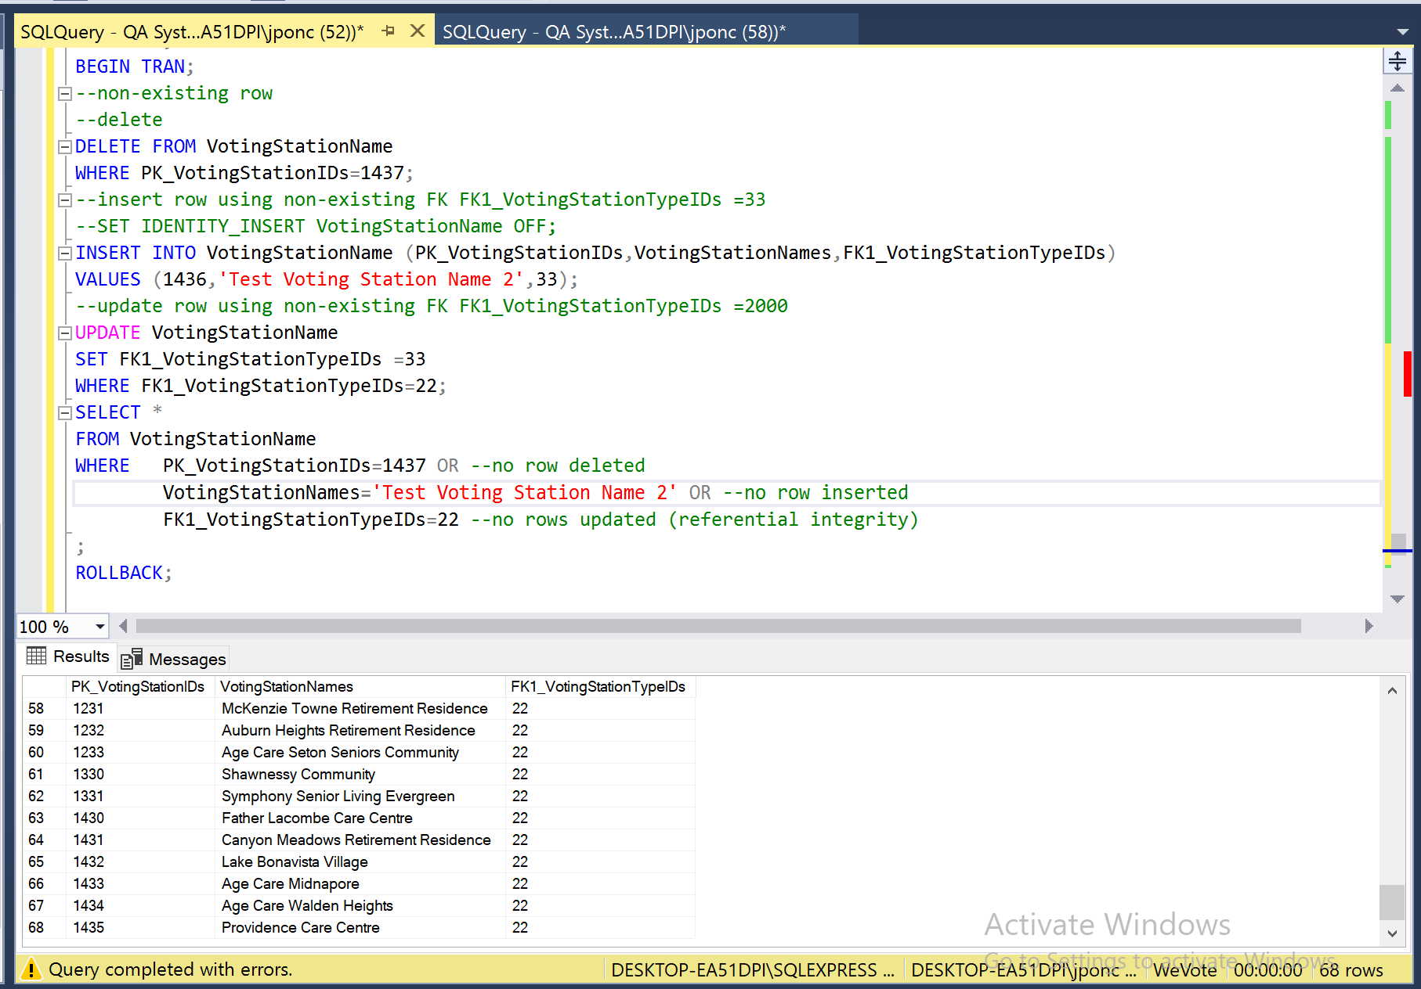

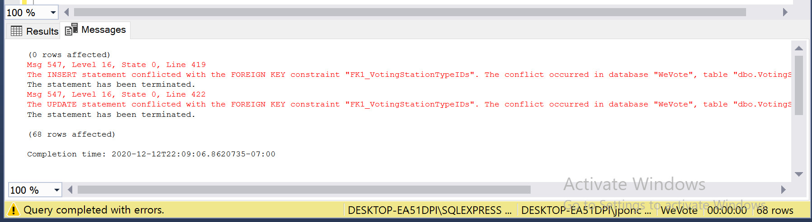

# **Check for NULLS**

## For table VotingStationName:

The fig below show the column that allow Nulls



Executing

Begin Transaction

insert into VotingStationName (PK_VotingStationIDs,FK1_VotingStationTypeIDs)

Values('1','11')

Error “Cannot insert the value NULL into column 'VotingStationNames', table 'WeVote.dbo.VotingStationName'; column does not allow nulls. INSERT fails.” Was generated because null are not allowed in VotingStationNames columns

**No check constraint in Table VotingStationName**